1) If in a certain language KINDLE is coded as ELDNIK, how is EXOTIC coded in that code?
a) EXOTIC b) EXOTLC c) CITOXE d) COXITE e) None of these
2) In a certain code BREAK is written as ASDBJ.How is SOLAR written in that code?
a) RPKBS b) TPMBS c) RPKBQ d) TPKBQ e) None of these
3) In a certain code ’GONE’ is written as ’NOEGG’ and ’LOAD’ is written as ’AODLL’. How is ’SORT’ written in that code?
a) ROSTT b) ROTSS c) RSTOO d) OTRSS e) None of these
4) In a certain code BLACK is written as ’ALBKC’ and SMART is written as ’AMSTR’ .How is CLOCK written in that code?
a) CLOKE b) CLOCK c) OLCKC d) OLCCK e) None of these
5) In a certain code Ianguage BANKER is written as 'LFSCBO’. How will CONFER be written in that code?
a) GFSDPO b) FGSDOP c)GFSEPO d) FHSDPO e) None of these
6) in a certain code MEADOW is written as BFNVNC .How is CORNER written in that code?
a) DPSQDM b) SPDMDQ c) SPDQDM d) DPSMDQ e) None of these
7) In a certain code CROWNED is written as PSDVEFO. How is STREAMS Written in that code?
a) SUTDBNT b) TUSDTNB c) SUTFTNB d) QSRDTNB e) None of these
8) In a certain code if LOUD is written as JQSF then which of the following English words shall be coded as PKQG?
a) RISE b) ROPE c) ROAD d) RICE e)None of these
9) In a certain code GATHER is written as UBHQDG. How is DESIGN written in that code?
a) EFTMFH b)TFEHFM c) TFEMFH d) TFEOHJ e) None of these
10.In a certain code BEND ls written as '5134‘ and DIAL is written as ‘4926’. How is LINE written in that code?
a) 6394 b) 6943 c) 6931 d) 6134 e) None of these
11.In a certain code language DOWN is written as 5139 and NEAR is written as 9486. How is RODE written in that code language ?
a) 6154 b) 6514 c) 9154 d) 3154 e) None of these
12.In a certain code language 'DEAR' is written as %#$?, ‘RED’ is written as “?#%’. ‘MORE’ is written as ‘@*?#'. how is ‘DREAM’written in that code ?
(1)#?%$@ (2)#%?$@ (3)%?#$@ (4)%?#$@ (5) None of these
13.If E ls replaced by 2, R by 5.T by 7, D by 3,S by 4,l by 6 and N by 9 then how is RESIDENT written if its letters are reversed?
(1) 79326425 (2) 79236425 (3) 52463927 (4) 54263927 (5) None of these
.Directions (14-18) : Study the following information to answer the glven questions :
In a certain code “new banking systems” is coded as “ss tp na", “officer in uniform” is coded as “or mu at”, . “new bank officer” is coded as ”or bk na” and “systems in bank” is coded as “bk at ss”.
14. What does the code “bk” stand for?
(1) new (2) systems (3) officer (4) in (5) None of these
15. What will the code “ss mu” stand for ?
(1) banking officer (2) new uniform (3) uniform banking (4) in systems (5) uniform systems
16. How will “new officer” be coded?
(1) or na (2) tp na (3) na at (4) tp or (5) ss at
17. How will "‘bank officer in uniform” be coded ?
(1) ss na at or (2) bk at or mu (3) ss na bk at (4) at mu ss or (5) bk ss mu na
18. What is the code for “in” ?
(1) as (2) or (3) at (4) mu (5) None of these
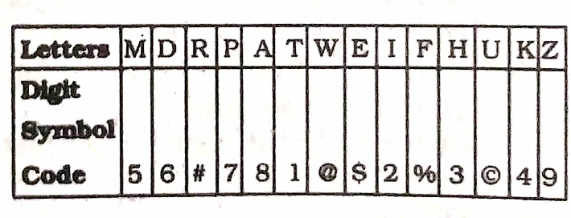
19.Directions (19-23) : In each question below is given a group of letters followed by four combinations Of digits/ symbols numbered (1), (2), (3) and (4). You have to find out which of the combinations correctly represents the group of letters based on the following coding system and the conditions and mark the number of that combination as your answer. If none of the four combinations correctly represents the group of letters, give (5) i.e. ‘None ofthese’ as the answer. Conditions:
(a) If the first letter is consonants and the last letter is vowel their codes are to be inter changed.

(b) If both the first and the last letters are vowels, both are to be coded as *.
(c) If the first letter is a vowel and the last letter is consonant, Both are to be coded as the code for the consonant.
19. TUKDIP (l) 1©4627 (2) 1©4621 (3) 7©4621 (4) 1©6427 (5) None of these
20. EFDMKA (1) $%6548 (2) $%654$ (3) *%654* (4) 8%6548 (5) None of these
21. APWTUH (1) *7@1©* (2) 87@1©3 (3) 37@1©8 (4) 87@1©8 (5) None of these
22.MARTWE.(l) 58#1@$ (2) 58#1@5 (3) $8#1@5 (4) $8#1@9 (5) None of these
23. HEMKZI (1) 2$5493 (2) 3#5492 (3) 3$5493 (4) 2$5492 (5) None of these
24.If ‘white’ means ‘black’: ‘black’ means ‘red’; ‘red’ means ‘blue’, ‘blue’ means ‘yellow’ and ‘yellow‘ means ‘grey', then which of the following represents the colour of clear sky ?
(1) blue (2) red (3) yellow (4) Cannot be determined (5) None of these

25.If ‘black‘ means 'yellow', ‘yellow‘ means ‘blue’, ‘blue’ means ‘green‘, ‘green’ means ‘white’ and ‘white’ means ",red then which one of the following will represent the colour of ‘milk’ ? (1) white (2) green (3) red (4) black (5) None of these

